The online assignment five

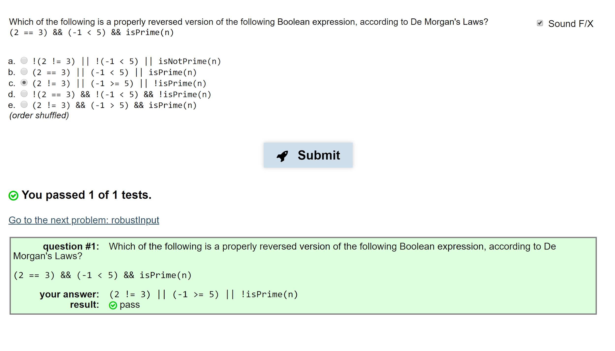

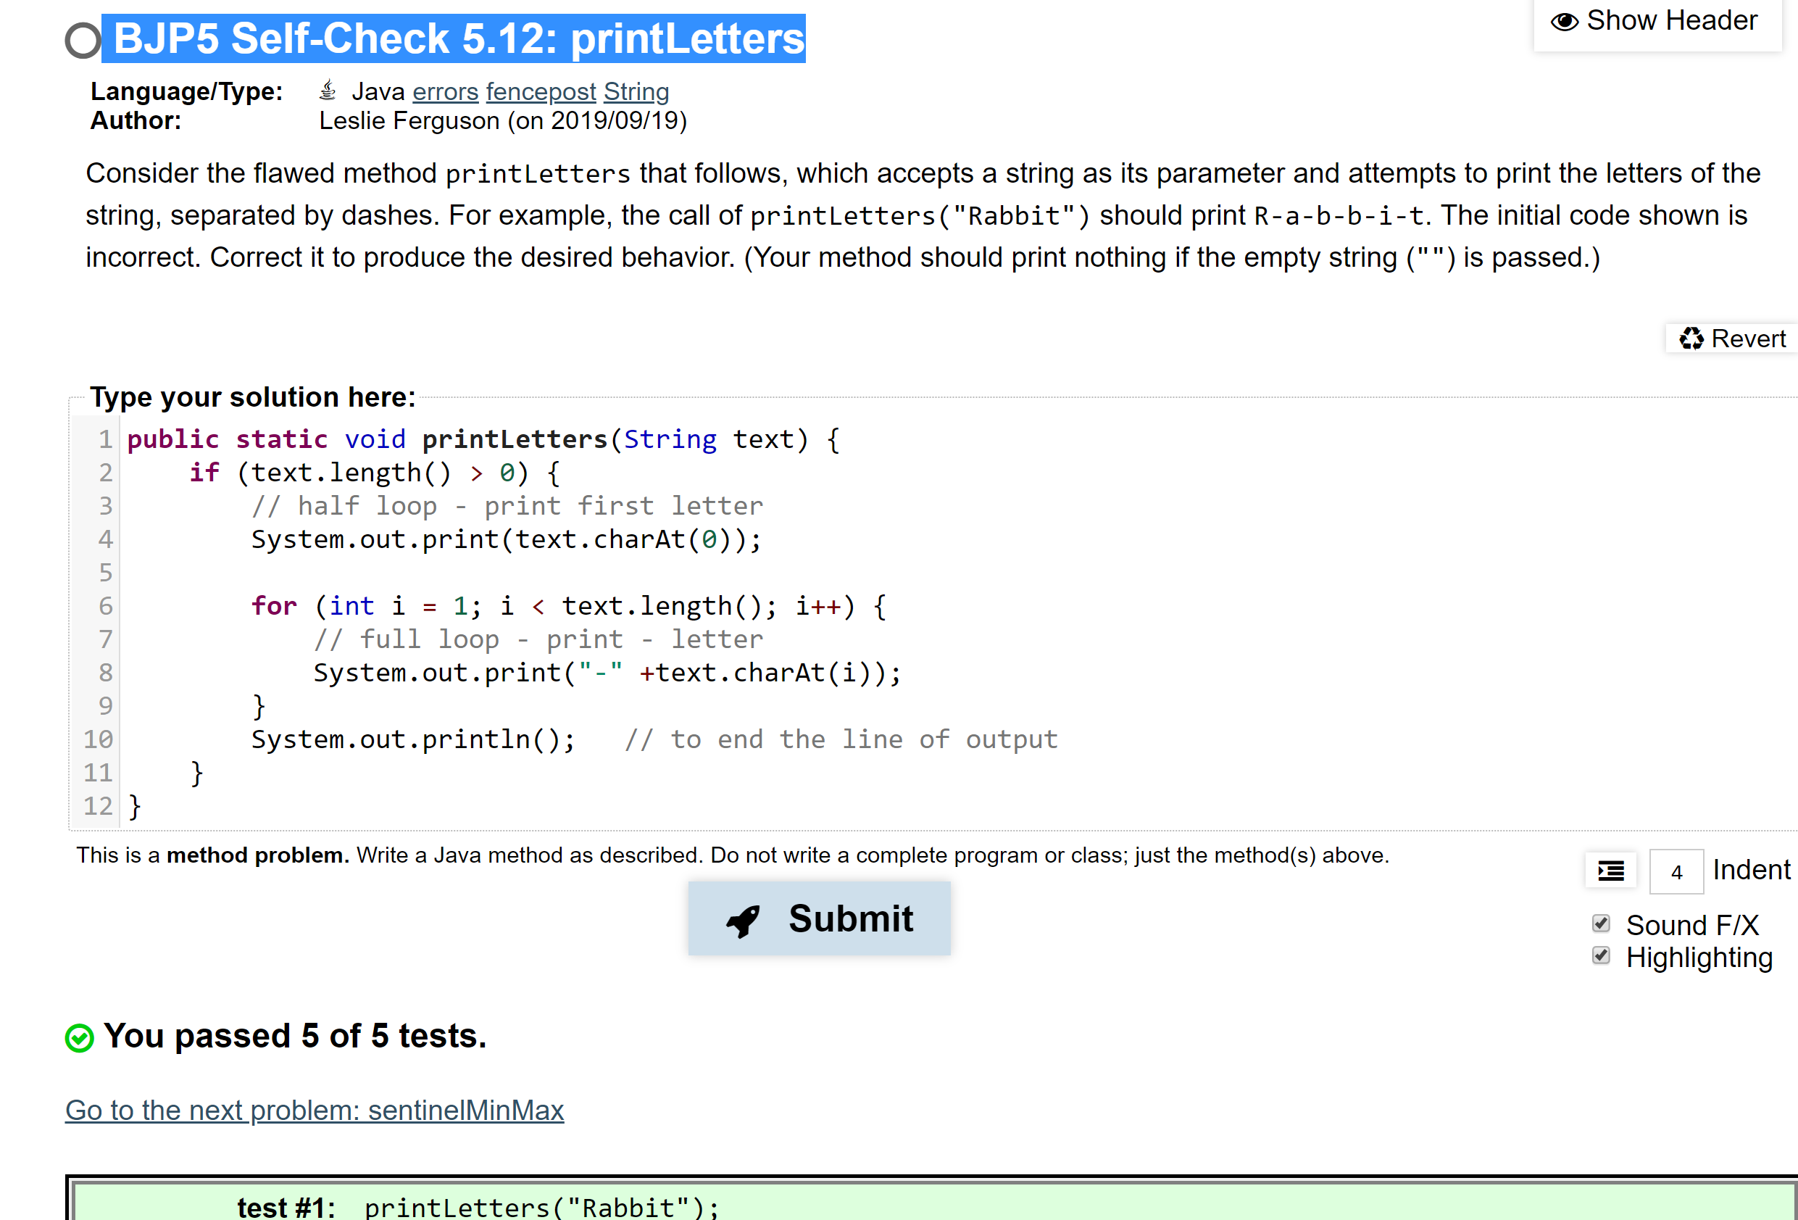

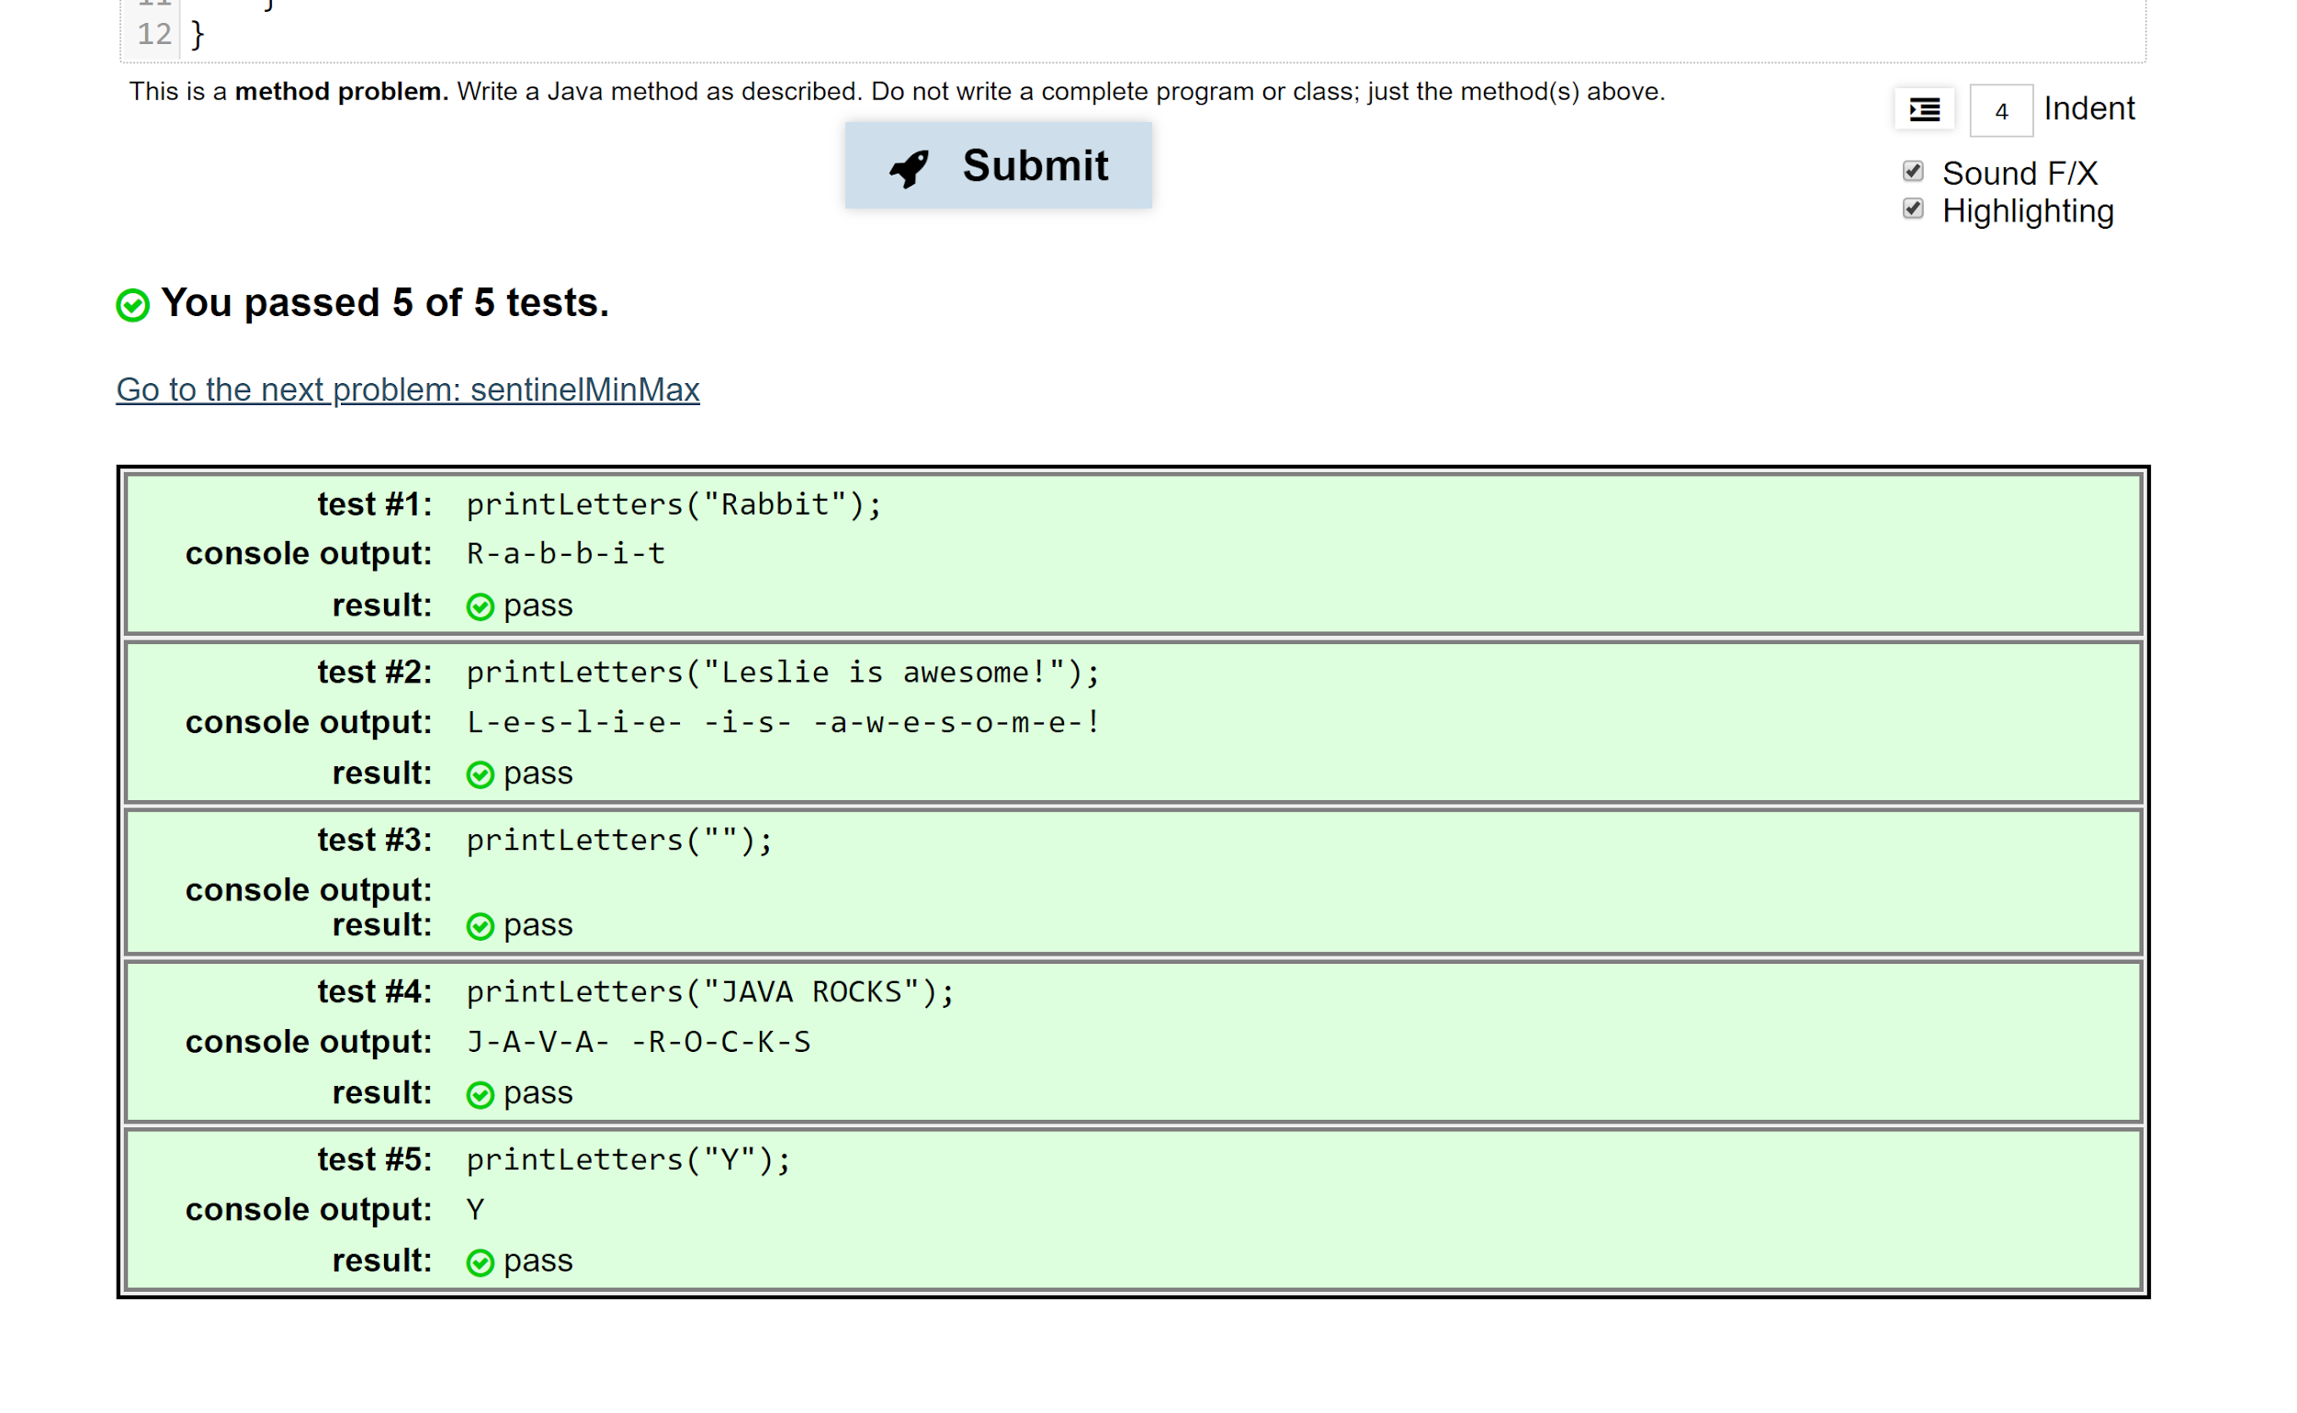

3) <https://practiceit.cs.washington.edu/problem/view/bjp5/chapter5/s9-doWhileSeashore>

4) <https://practiceit.cs.washington.edu/problem/view/bjp5/chapter5/s16-isPrime>

5) <https://practiceit.cs.washington.edu/problem/view/bjp5/chapter5/s17-contains>